**Short Report - Assignment 1**

*I have replaced playlist with RapCaviar, playlist_id = '37i9dQZF1DX0XUsuxWHRQd'. There are 50 songs in it.*

For task 1, I chose the feature 'energy' to explore. I chose the top 10 songs in order of highest 'energy'( **p1** ). In this playlist, I can feel that the energy of these ten songs is high, the tempo is fast and upbeat, and the music fluctuates so much that you can't help but move.

Then I selected the top 10 song in order of lowest 'energy'.( **p2** ). I can feel the lower energy, slower tempo and slower rhythm of these ten songs. They give me a slow and relaxed feeling.I was able to get a clear sense of the difference in energy between the two top 10 lists. This supports the accuracy of this feature to a certain extent.Looking further at one of the top 10 lists, subjectively I am ambivalent about their list sorted by energy.For example, 'Kevin Gates - Do It Again' with an energy score of 0.718 is more explosive to me than 'DaBaby - SHAKE SUMN' with an energy score of 0.768.

At first I wasn't sure what the ranking of 'acousticness' was based on, but after comparing the highest score to the lowest, I could tell that it was based on the number of instruments used in the song.Overall, this sorted order of the playlist flows well.However, as I am not a professional, I cannot judge the musical differences in the single-digit ranking of the gaps.

With regard to task 3, Top N Recommendations are actually decided on the basis of the score of SONG similarity.For the song I chose, the recommendations after n=20 became irrelevant in the context that all features were included in the calculation, as they had a negative Song Similarity.When I reduced to the remaining three features of 'danceability', 'energy', and 'acousticness', the recommendations became irrelevant after n=21. And three of the first ten recommendations in recommendation ( **p3** ) are the same as before, suggesting that the recommended songs are different in the context of different features.

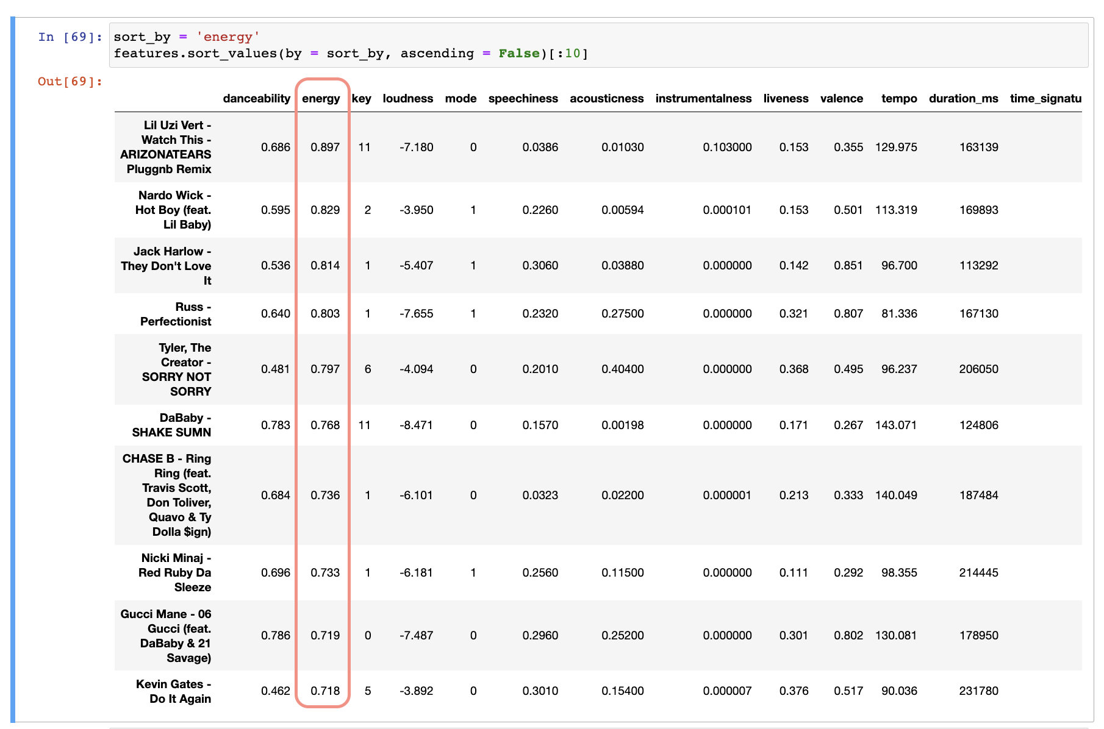

**P1**



**P2**

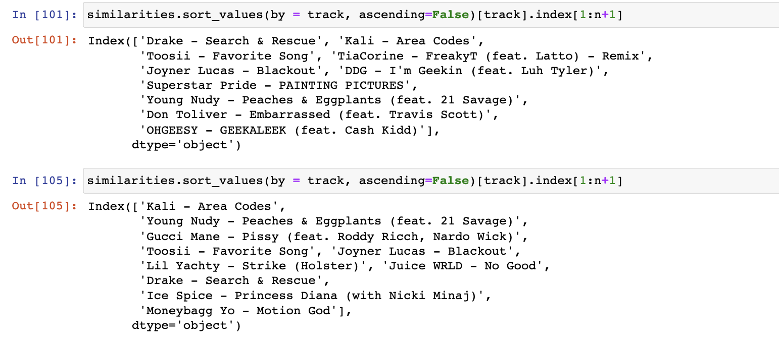

**P3**